180
www.victronenergy.com
Выключатель АКБ

Battery Switch 275 A
Выключатель аккумуляторов
Максимальный постоянный ток | 275 Ампер
Максимальный ток в течение минуты | 450 Ампер
Пиковый ток | 1200 Ампер
Напряжение | 48 Вольт
Материал терминалов | Луженая медь
Материал гаек | Луженая медь
Сечение терминалов | 9.53 мм
Крутящий момент монтажа | 8 Н/метр
Материал корпуса | Нейлон
Вес | 0.2 кГ
Размеры | 69 x 69 x 73 мм
Mounting | Surface or rear panel mount
Ignition protected | ISO8846 / SAE J1171

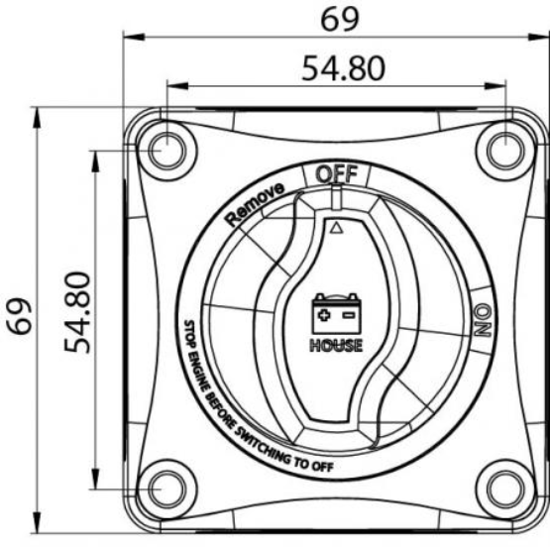
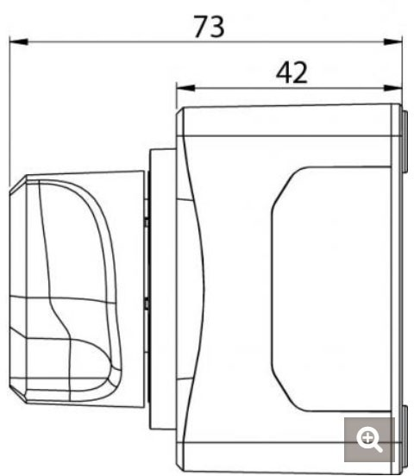

Victron Energy B.V. | De Paal 35 | 1351 JG Almere | The Netherlands General phone: +31 (0)36 535 97 00 | E-mail: sales@victronenergy.com www.victronenergy.com

