www.victronenergy.com
Корпус с 6 предохранителями

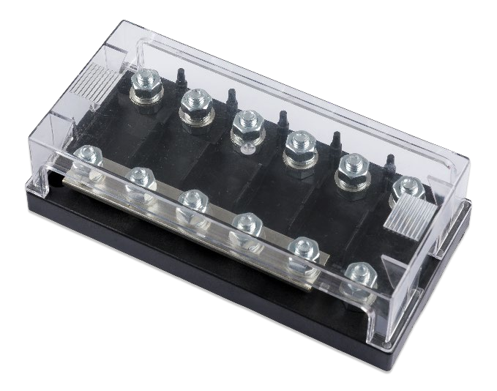
Корпус с 6 предохранителями
Максимальный ток | 250 Ампер
Максимальное Напряжение | 70 Вольт
Диаметр терминалов | 8 мм
Высота терминалов | 14 мм
Материал терминалов | Гальваническая сталь
Материал гаек | Гальваническая сталь
Усилие крутящего момента | 7 Н/метр
Покрытие шины | Луженая медь 3 x 18 мм
Материал корпуса | Пластик ABS, UL 94 V-0
Материал крышки | Поликарбонат, UL 94 HB
Вес | 0,45 кГ
Размеры с крышкой | 50.9 x 181.5 x 88 мм

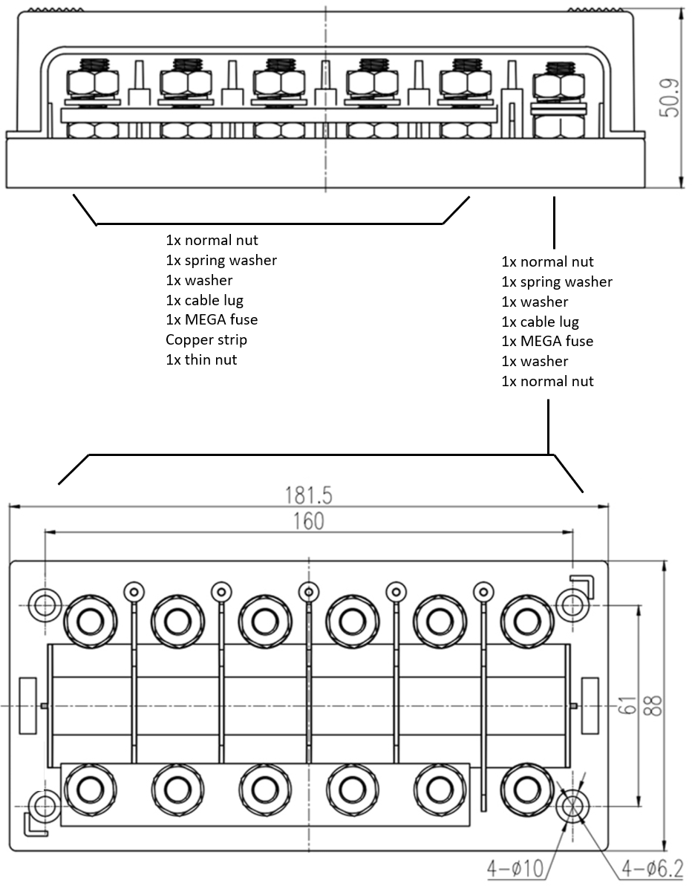

Victron Energy B.V. | De Paal 35 | 1351 JG Almere | The Netherlands General phone: +31 (0)36 535 97 00 | E-mail: sales@victronenergy.com www.victronenergy.com

